**NAME: AMMAAR AHMAD**

**ROLL: 1801CS08**

1. Circuit Diagram for RISC single cycle processor

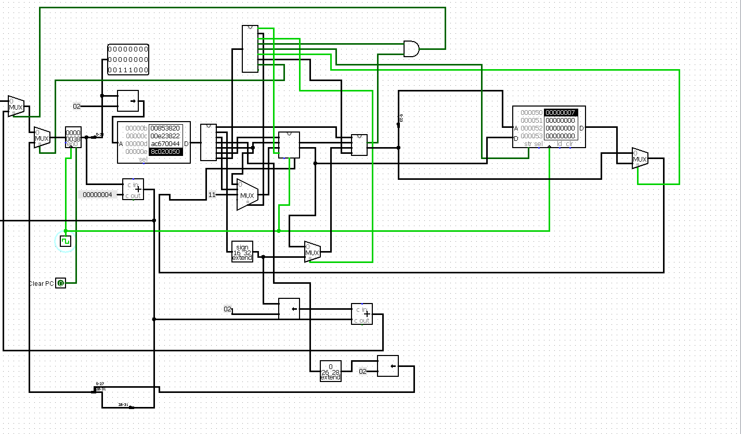

ROM loaded with given program Machine code

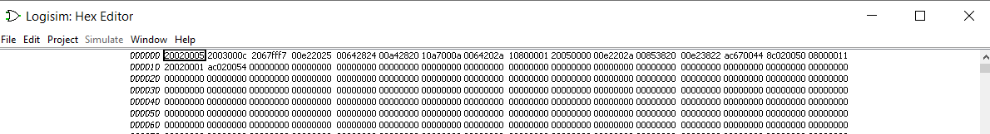

Final Output: 7 is stored in memory location 80(50 Hex) and 84(54 Hex)

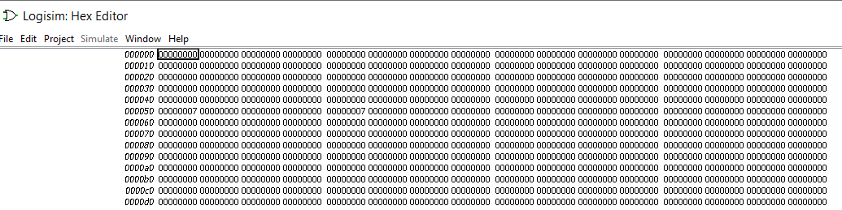

1. Program to add 5 numbers.

Initially 5 numbers are stored in registers no 1 to 5.

$1 = 34, $2 = 21, $3 = 15, $4 = 45, $5 = 12, Result of addition $6 = 0 initally

All numbers are in hexadecimal form. Final Result $6 = C1(Hex)

52+33+21+69+18=193=C1(Hex)

MIPS code Machine Code

addi $1, $0, 52 0x20010034

addi $2, $0, 33 0x20020021

addi $3, $0, 21 0x20030015

addi $4, $0, 69 0x20040045

addi $5, $0, 18 0x20050012

addi $6, $0, 0 0x20060000

add $6, $1, $2 0x00223020

add $6, S3, $6 0x00663020

add $6, $4, $6 0x00863020

add $6, $5, $6 0x00A63020

sw $6, 32($0) 0xAC060020

ROM loaded with Machine Code

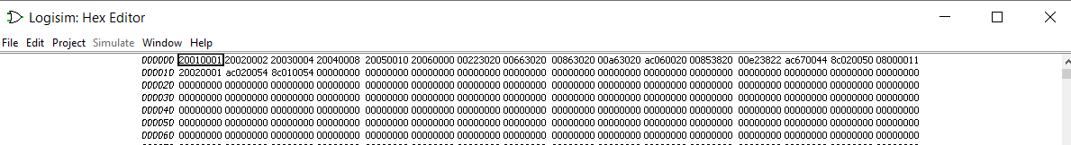

Before running instructions

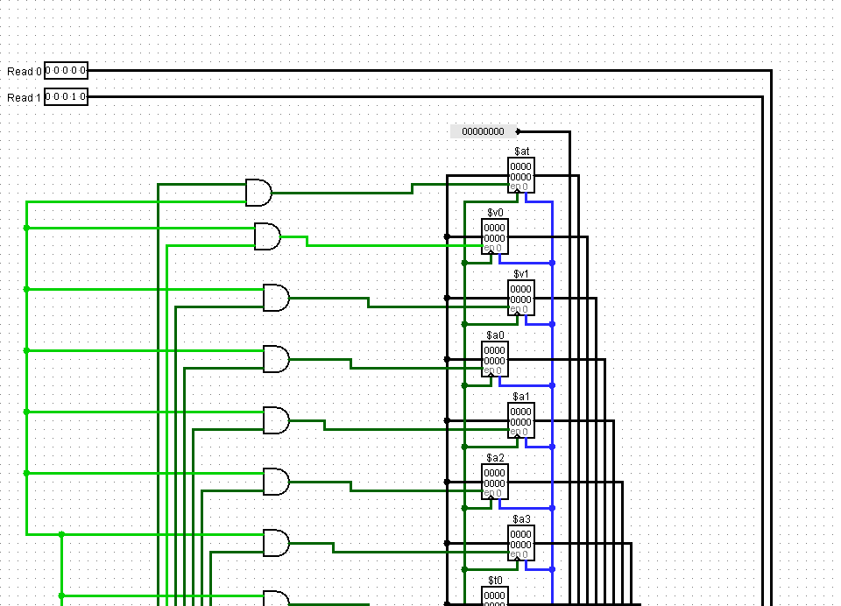

Before Addition after storage in registers

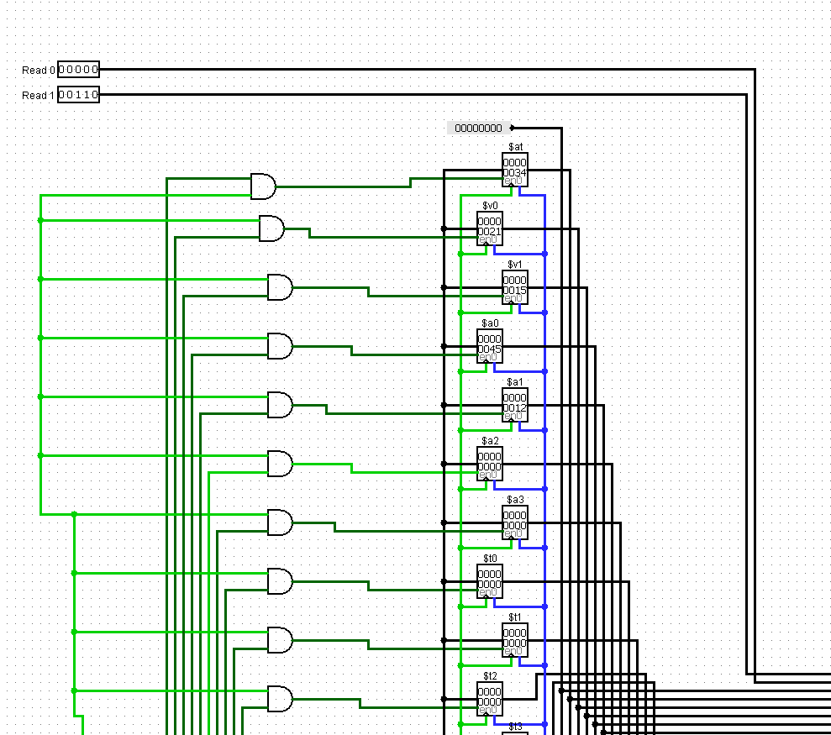

After addition $6=C1

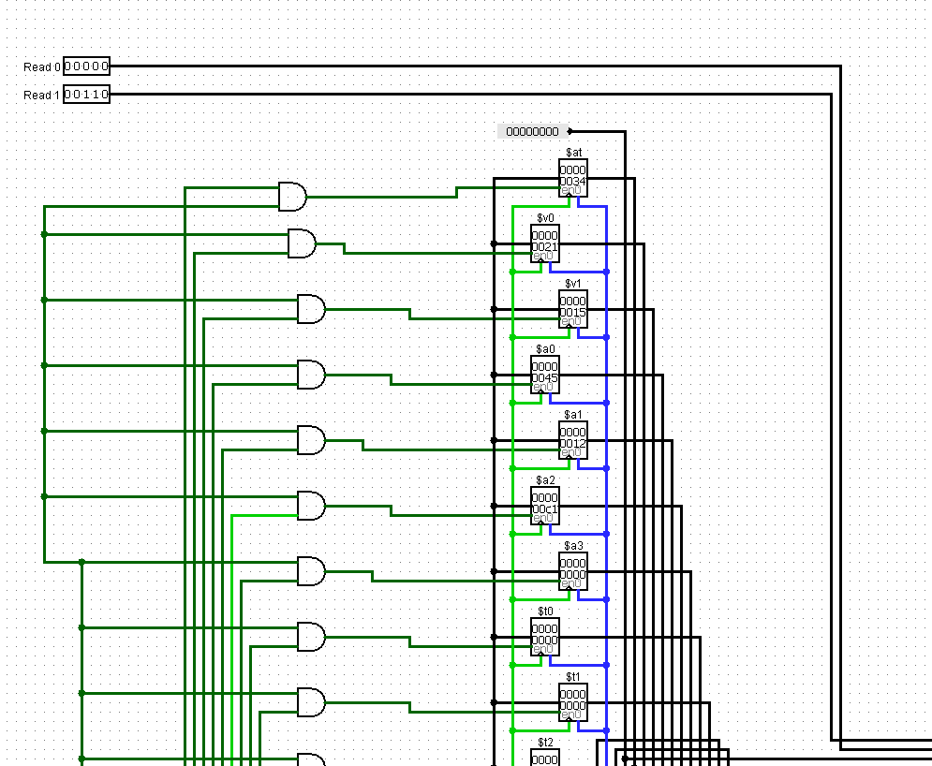

Memory location 32 or 20(Hex) has stored sum = 193=C1 in Hex

